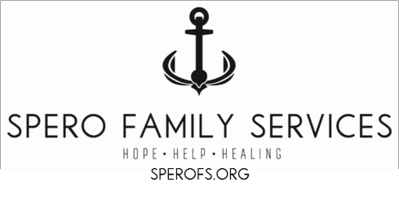
Spero Home Visiting Referral

Date of referral: DCFS ID if applicable:

Referred by: Name of DCFS/POS worker Agency Name & Location
Phone:
Email: Names family members and ages of children being referred:
Name: Age:
If expecting, how many weeks pregnant or EDC?
Name: Age: Name: Age: Name: Age:
Family Contact Information
Phone:
Address:
Child and Family strengths/interests:

Child and Family needs/reason for referral:

Safety Concerns:

Please submit form and/or questions to email hvs@sperofs.org
phone:618-315-3003 fax 866-535-7465

Office Use Only:
- Referral forwarded to PAT NPP NFP Other: on
- Referral declined by participant
- Referral unable to be reached/letter mailed

Spero Family Services Authorization for Release of Information

I, , authorize, Spero Family Services (Agency/Facility/Person)

to: Release to: Obtain from: Exchange with:

, (Agency/Facility/Person) (Address)
Information concerning DOB / / . Specific Nature of Information: Social History Medical Records School Records/IEP
Admission/Discharge Summaries Progress Notes & Incident Forms Psychiatric or Psychological Assessments Court Orders/ Legal Concerns
Other_Information needed to complete referral and intake into services provided by Spero Family Services.

This information may be released by mail, phone, fax, electronic transmission, or verbally and will be used for the purpose of: Provision of Social Services Provision of Special Education Casework Planning

Other

This authorization is valid until / / _, unless otherwise revoked.
Consents for release of information are valid for a maximum of one year; one time release of information is valid for a maximum of 90 days.

I understand that I may revoke this consent at any time, and that such revocation must be in writing.
I further understand that above named agency/facility/person authorized to receive this information has the right to inspect and copy the specific information being disclosed.

I understand that if I refuse to authorize this release of information the following consequences may occur: the Agency will be unable to receive the requested information and may affect the decisions regarding my referral, progress, and/or provision of services.

It is my full understanding that the records and communications to be disclosed contain evaluation and/or habitation/treatment information for mental health, developmental disabilities and/or alcohol or substance use/abuse and that my signature indicates my informed consent.

X (Signature of client age 12 or older) (Date)

X (Signature of Parent/Guardian of client) (Date)

X (Witness) (Date)

A copy of this consent from was given/mailed to the client on: / /
(Worker’s signature)

Notice to receiving agency/facility/person: Under penalty of law and the provisions of the Illinois Mental Health and Developmental Disabilities Confidentiality Act (740 ILCS 110), you my not redisclose any information unless the person who consented to this disclosure specifically consents to such redisclosure. Under the Federal Act of July 1, 1975, Confidentiality of Alcohol and Drug Abuse Patient Records, no such records, nor information from such records, may be further disclosed without specific authorization for such redisclosure. Under the Illinois HIV/AIDS Confidentiality act, no records or information may be disclosed without specific authorization for such disclosure.

Revised 10/2020

